## Intelligent “Best Safety / Max Safety” Rating Generator for Restaurant

### Introduction

* Overview

Due to the COVID-19 pandemic, besides checking temperatures, they are mandating staff to wash hands at regular interval, change gloves, and ensure double wrapping of the food products. To ensure that people are fit to work, they measure and record the temperature of all staff before they begin work. One major expectation amongst these is to wear a mask. Wearing masks by employees in pubs, restaurants, places of worship and other businesses and organisations make contact tracing more efficient and help stop the spread of COVID-19.

* Purpose

To create an application that checks for the presence of masks using visual recognition. AWS Rekognition is used to train the model to enable detection. It will store the number of people not wearing masks in DynamoDB when it does not detect a mask. AWS Lambda and IAM services are used to accomplish this.

### Result

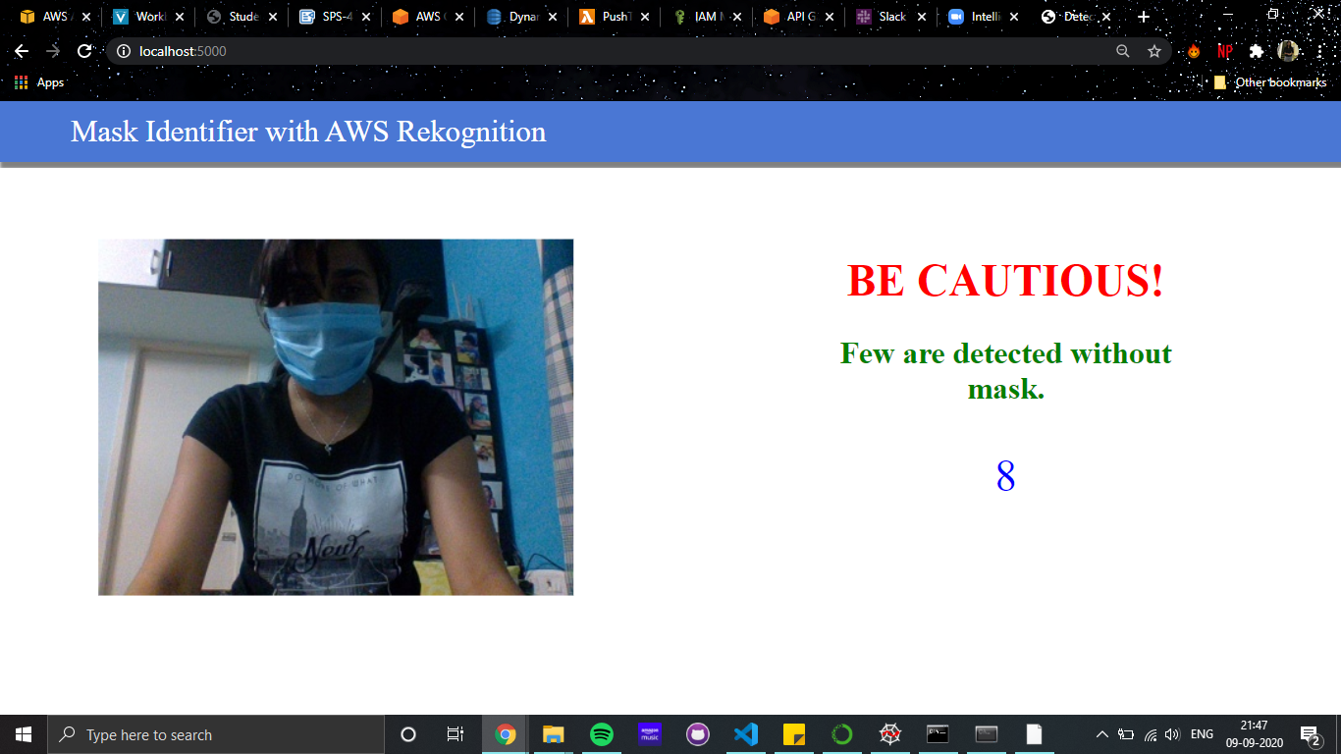

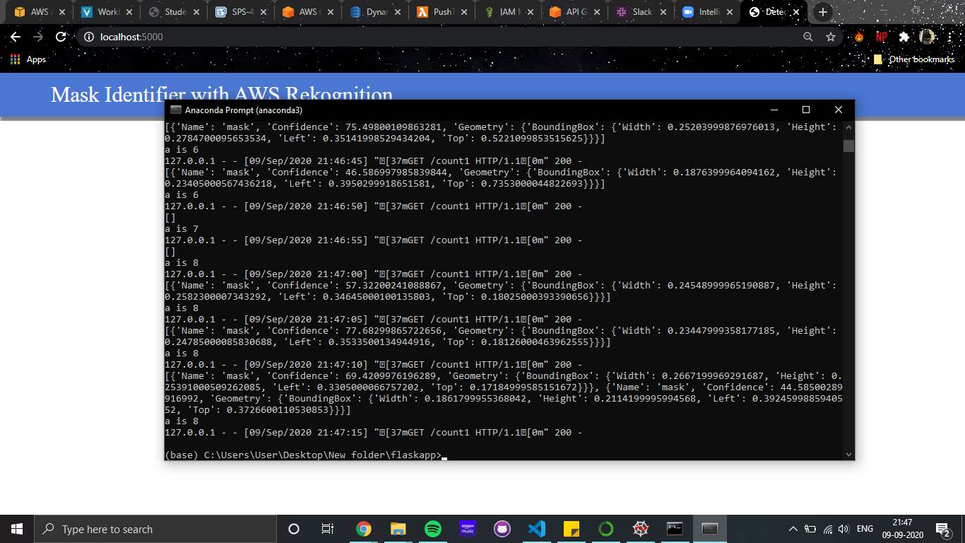

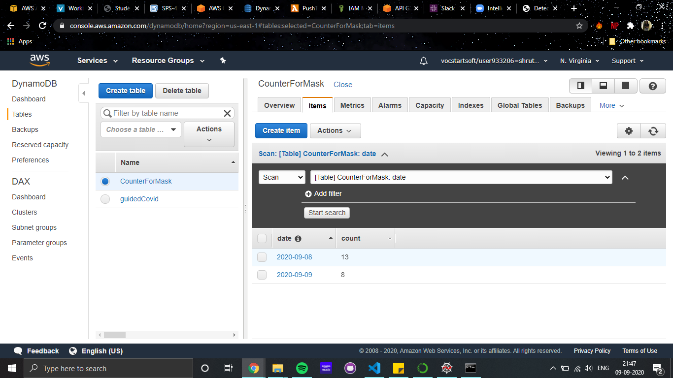

### Applications

With the Centre for Disease Control (CDC) issuing guidelines to safely reopen the country post-lockdown, restaurants and cafes will have to be extra careful while welcoming and serving their customers. The CDC guidelines specific for restaurants calls for a widespread change in behavior and business practices of restaurants.

In these cases, this application can be implemented in the restaurant to make sure the employees are wearing masks.

### Conclusion

This rating generator, at once, straddles the two worlds and cater to both small and big restaurants. They are economical, accessible, eco-friendly, and a perfect tool to help restaurants adhere to the changed realities of the world. And since people with minimal technical know-how do not have to involve in this implementation in their premises, once installed, they are probably the quickest way for restaurants to open their shutters with a new menu.

### Future Scope

These guidelines naturally stipulate social distancing and hygiene norms that restaurants will have to comply with. Among other things, CDC guidelines discourage the obsolescence of masks. This generator will create peace amongst the customers as well as the employees.